RDS SNAPSHOT

STEP 1:CREATE DATABASE
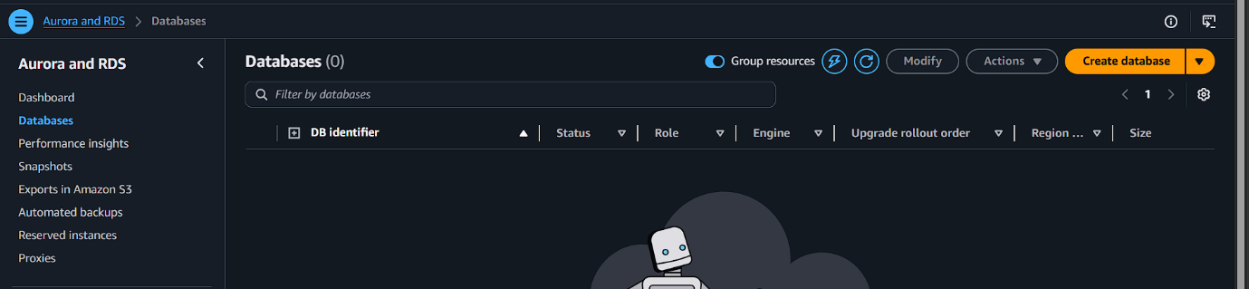
SELECT DB ENGINE
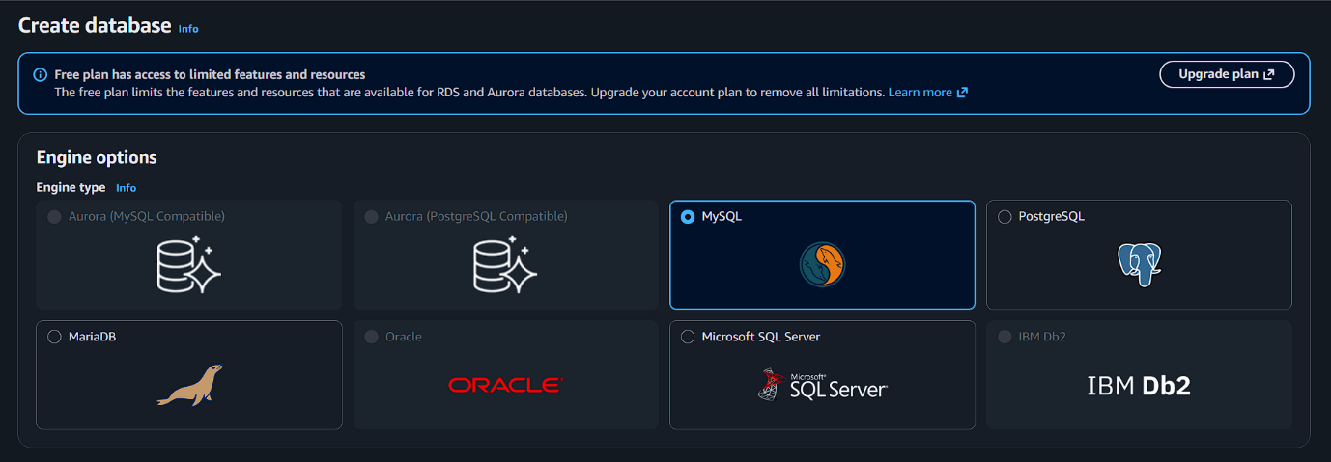
Use free tier
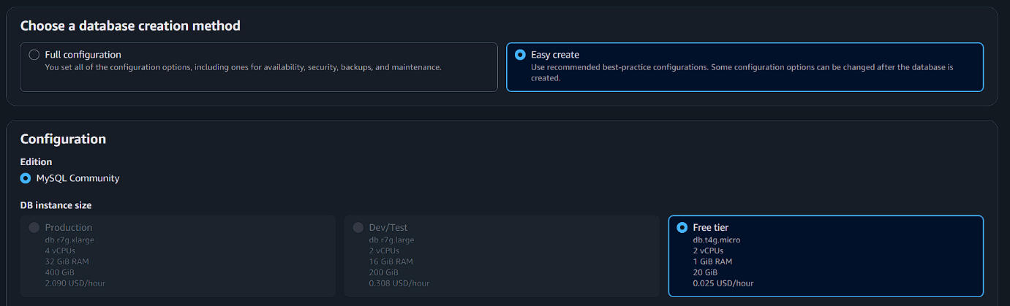
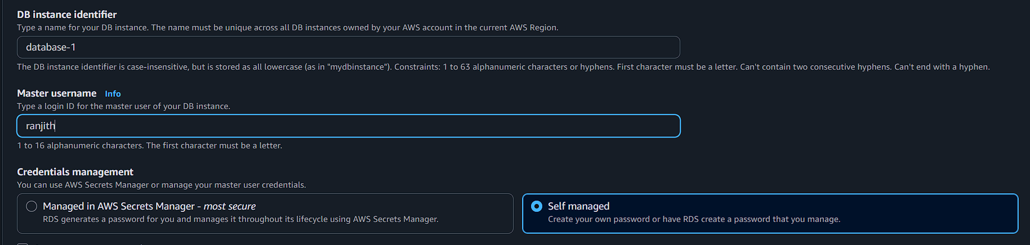

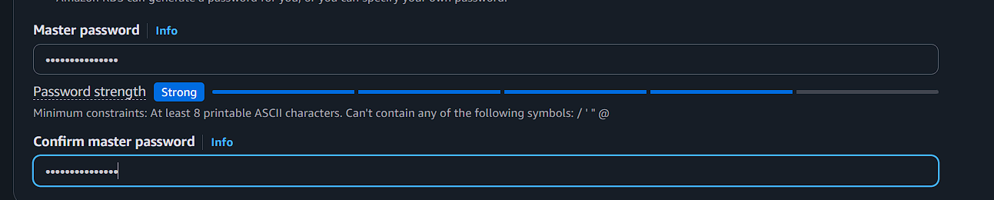
Step 2: create ec2instance
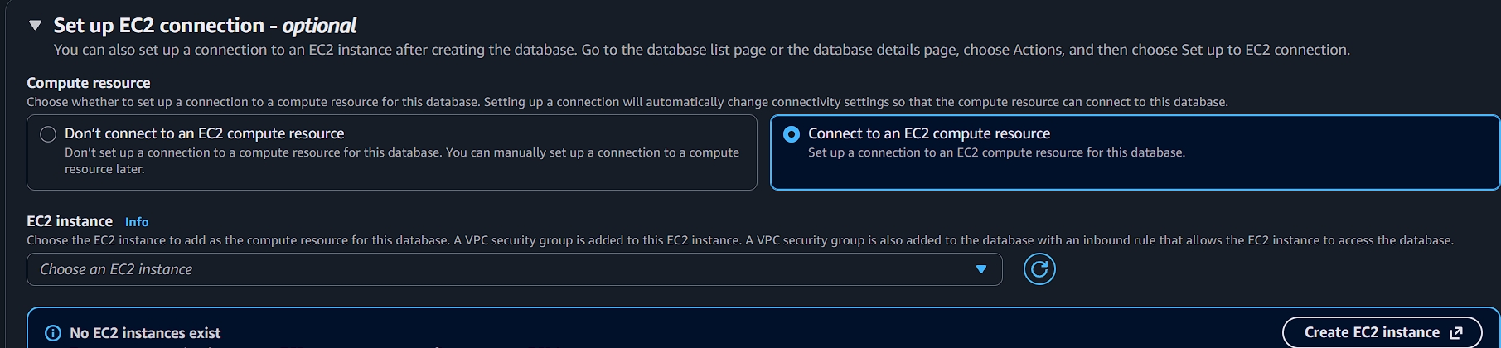
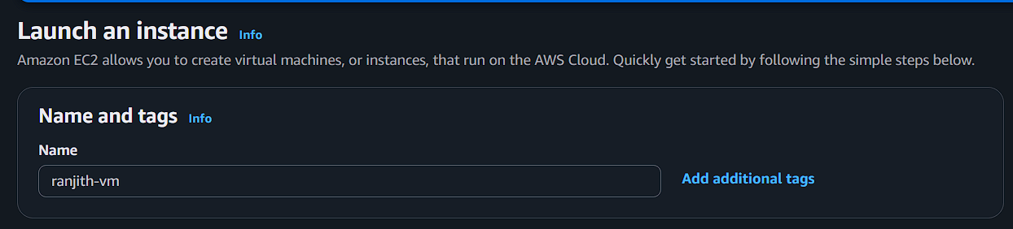
Insert port number 3306(mysql aurora)
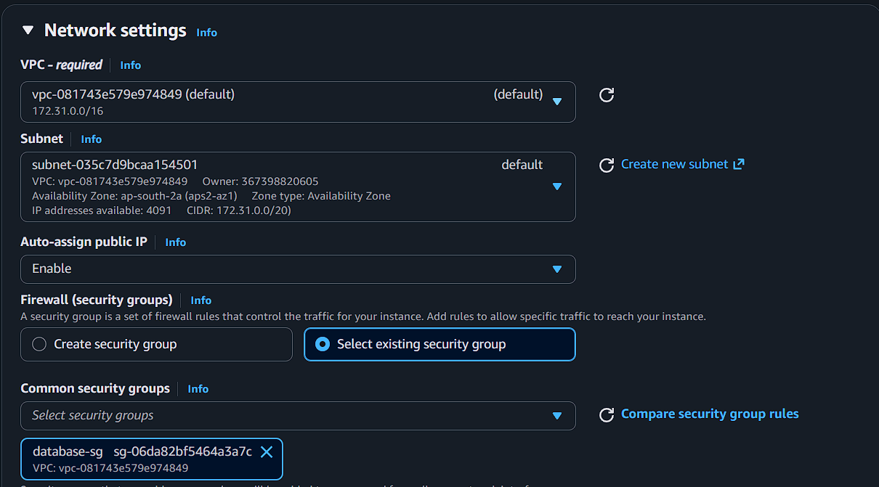
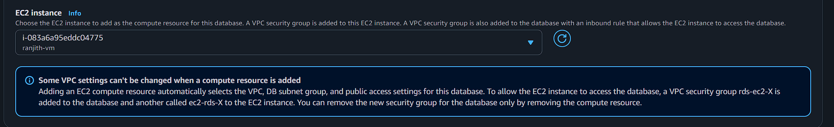
Connect the ec2 instance
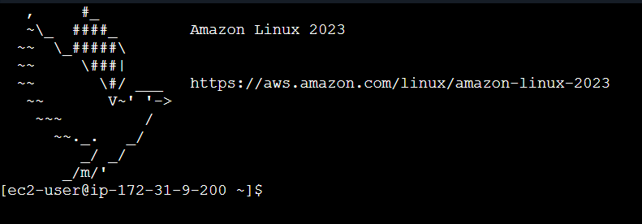
Select any one package and download
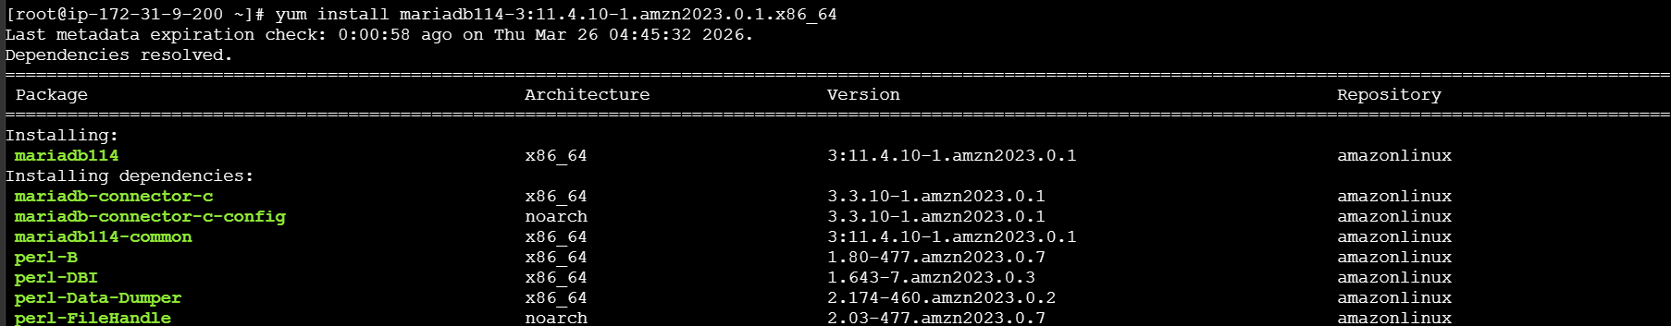
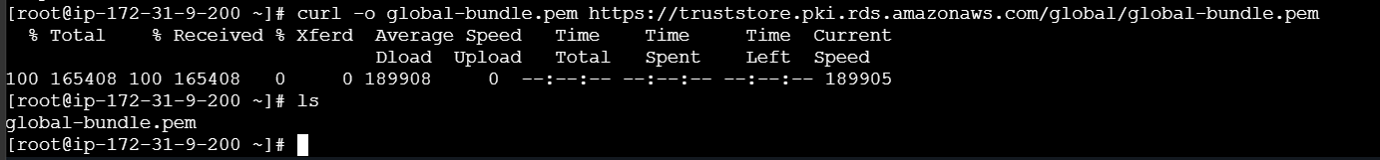
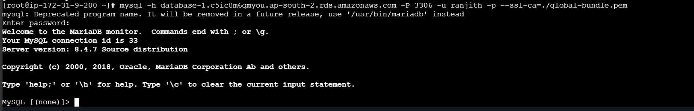
Now database are connected
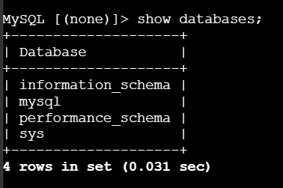
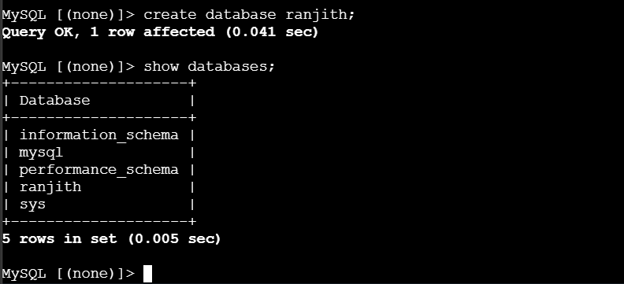
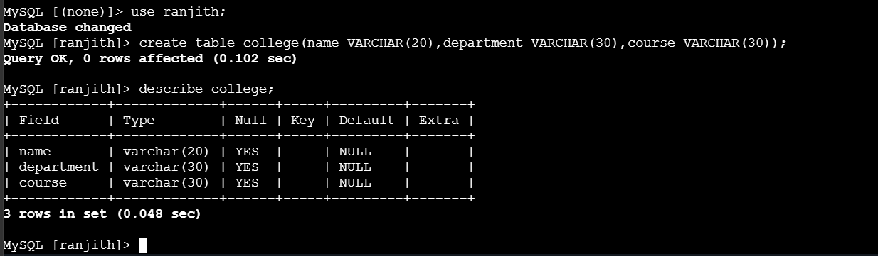
Now take a snapshor for DB
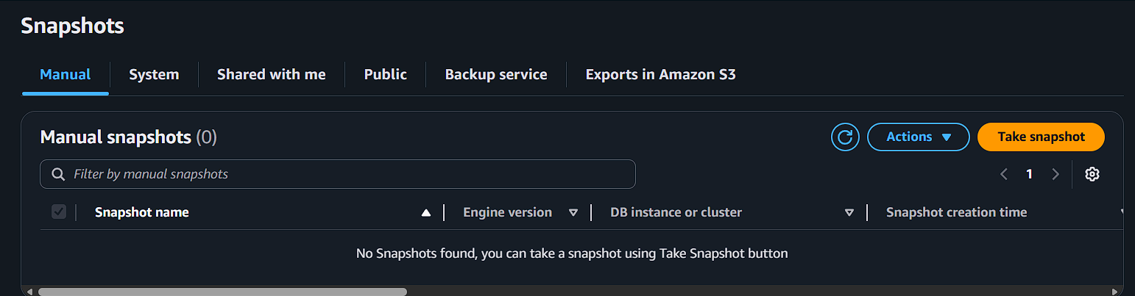
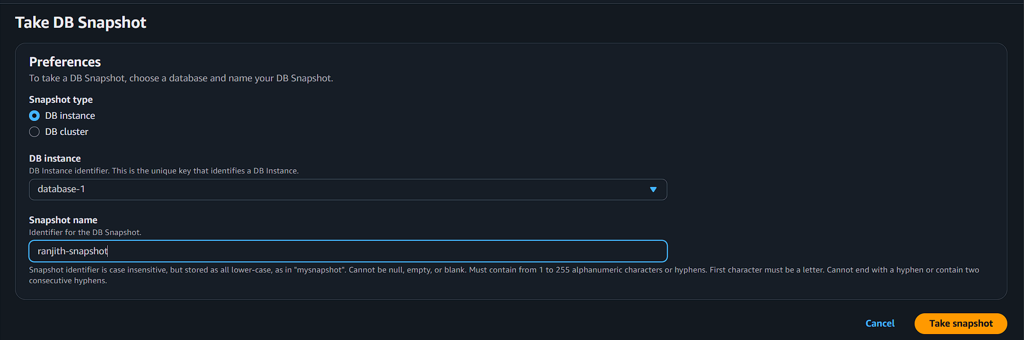
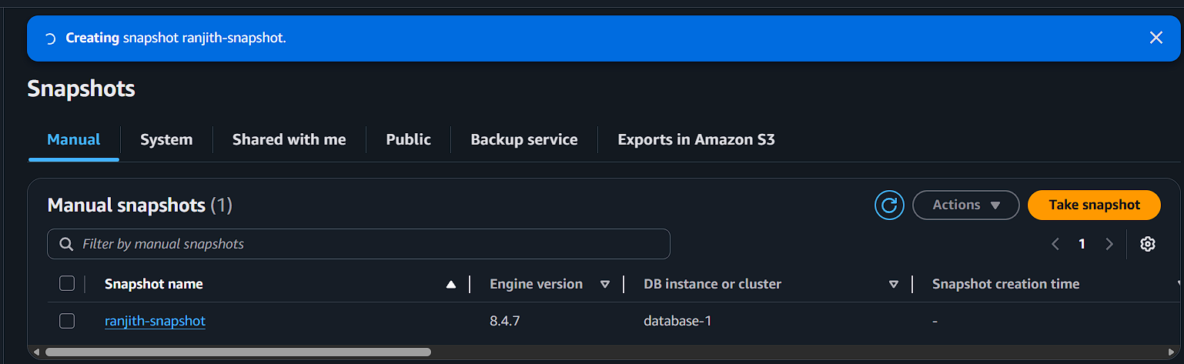
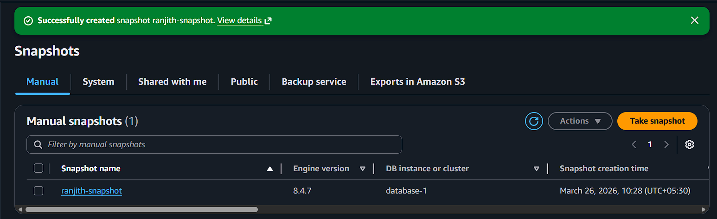
Delete the original database
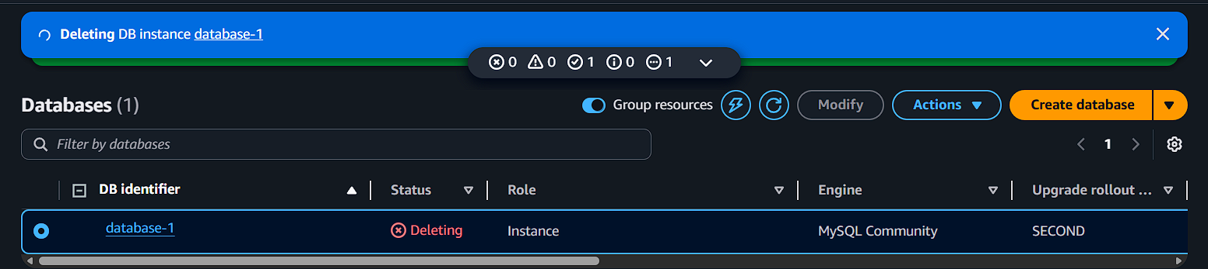

Restore the snapshot
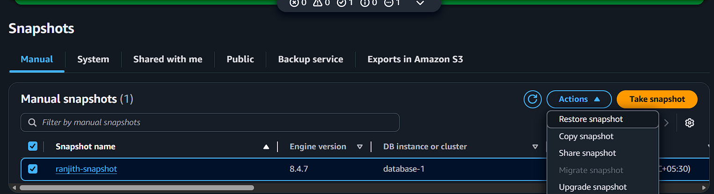
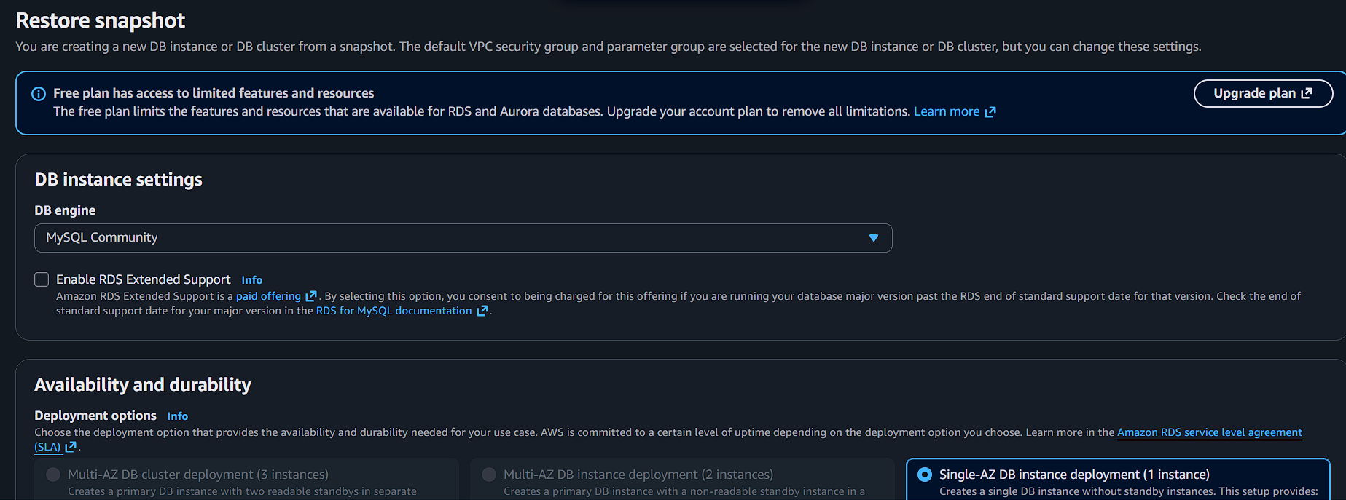
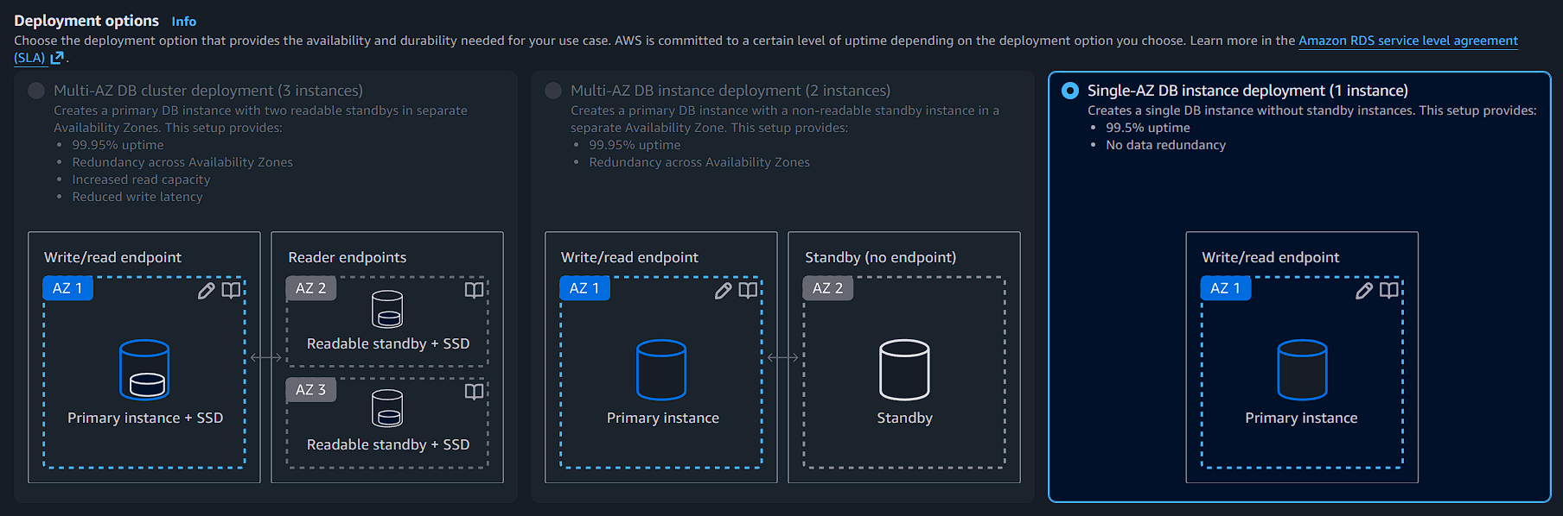
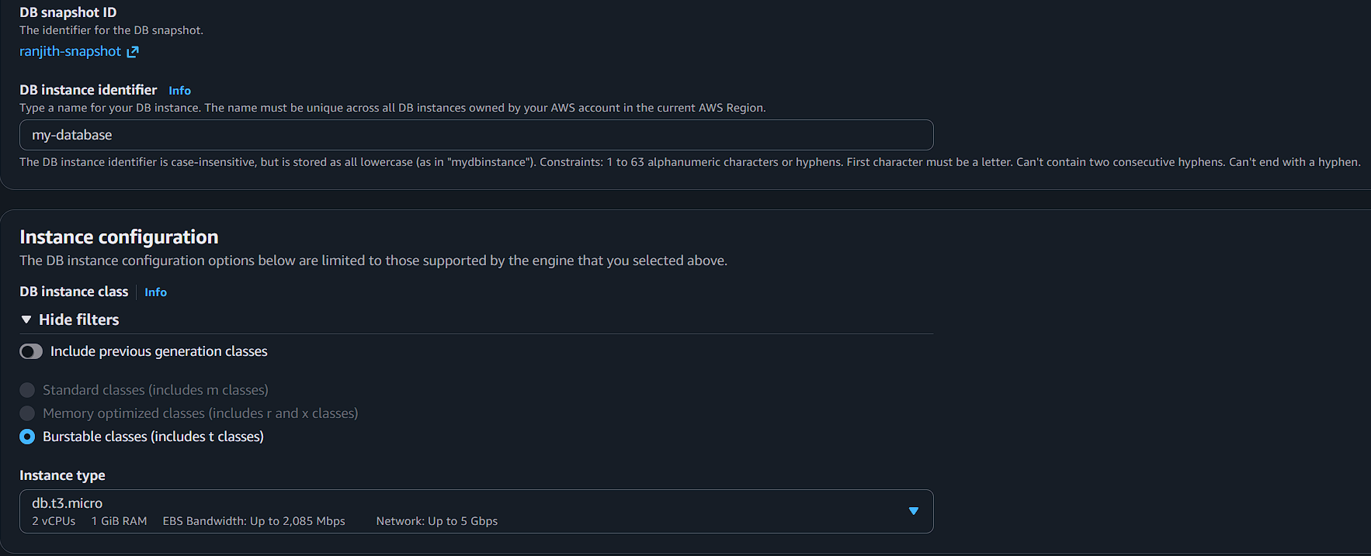

All options are default
Then click restore
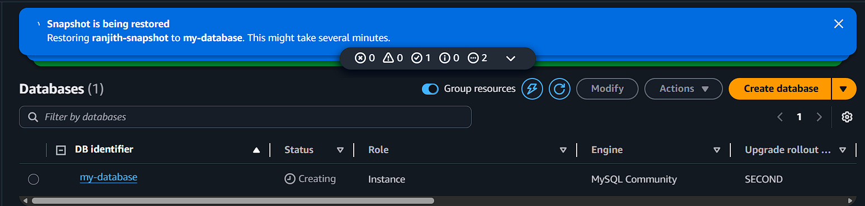
Now database has been creating
Waiting few minutes
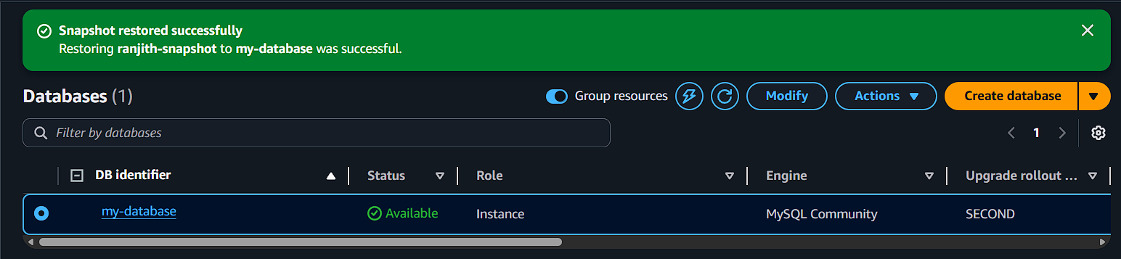

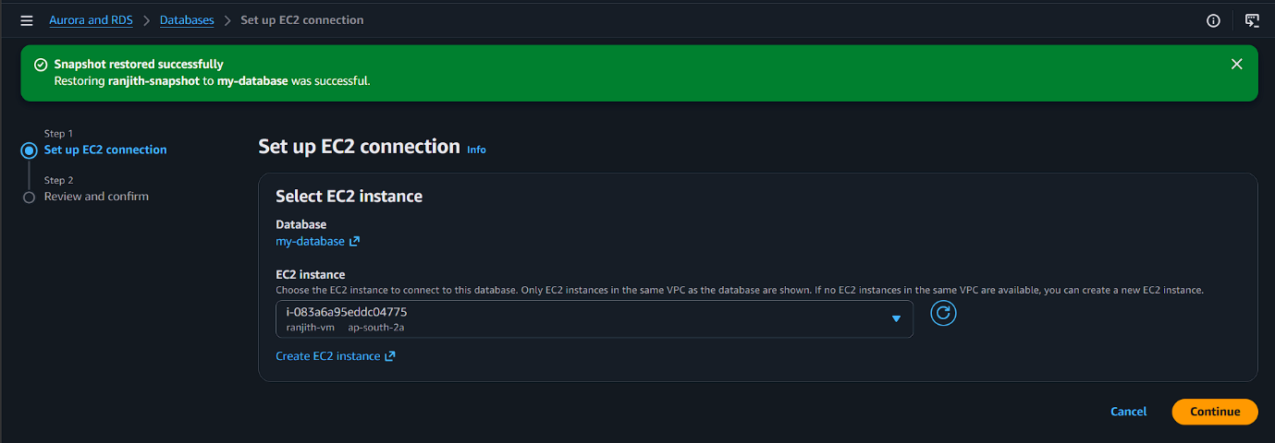
Now connect ec2 instance
